Supply Chain Digitization
Week 6 | Session 4: Building a Classification Tree — Gini Index, Splitting & Stopping
Session Agenda
- Recap — what the model does (from Session 3); now: HOW it was built
- Step 1 — Root node: baseline accuracy without any features
- Impurity measures — Gini Index and Entropy: formulas, examples, graph
- Step 2 — Splitting logic: choose variable + cutoff that maximises reduction in impurity
- Step 3 — Trace all node splits with Gini values and impurity reduction
- Stopping criteria — when to stop splitting
- Overfitting — why stopping is necessary
- Summary — 4-step algorithm for building a classification tree
- Next session: Python hands-on — build this exact model in code
Recap — Session 3 vs. Session 4
- Session 3: Showed the OUTPUT of the classification tree — 4 leaf node rules, predictions, how to use on shop floor
- Session 4: Explains HOW the tree was built — the algorithm behind it
- Core algorithm logic: Repeatedly split nodes by choosing the variable and cutoff that maximally reduces impurity → until a stopping criterion is met
Step 1 — Start with Root Node (Node 0)
- Training data: 700 instances (note: model uses 700, full dataset has 1000 — 700 used for training)
- At root (no feature information): 447 machines failed (Yes) | 253 did not fail (No)
- Baseline probability: 447/700 = 64% chance any randomly picked machine will fail
- Problem with baseline: 64% regardless of age, utilisation, oil contamination etc. — ignores all useful information
- Goal of the tree: Incorporate features to improve accuracy beyond the 64% baseline
- Gini at Node 0: 1 − (0.64² + 0.36²) = 1 − (0.41 + 0.13) = 0.46 (close to maximum of 0.5 → highly impure data → room to improve)
★ Starting accuracy = 64% (baseline). By splitting nodes using features, accuracy at leaf nodes improves to 77%, 83%, 88%. This improvement is what makes the model valuable.
Impurity Measures — Gini Index & Entropy
Why Impurity?
- Impurity = randomness in a node. A pure node = all observations belong to one class → perfect prediction.
- The lower the impurity at each leaf node, the higher the accuracy of classification.
- Goal at every split: choose the variable + cutoff that reduces impurity the most.
Gini Index Formula
Gini(t) = 1 − Σᵢ [ P(class i | node t) ]²
- k classes: For binary (k=2): Gini(t) = 1 − (p₁² + p₂²) where p₁ and p₂ are proportions of each class in node t
- Range: 0 (perfectly pure) to 0.5 (50-50 split — maximum impurity for binary)
Entropy Formula
Entropy(t) = − Σᵢ P(class i | node t) × log₂[ P(class i | node t) ]
- Range: 0 (perfectly pure) to 1 (50-50 split for binary — maximum impurity)
- In this course: Both explained conceptually. Gini index used in practice for this model.

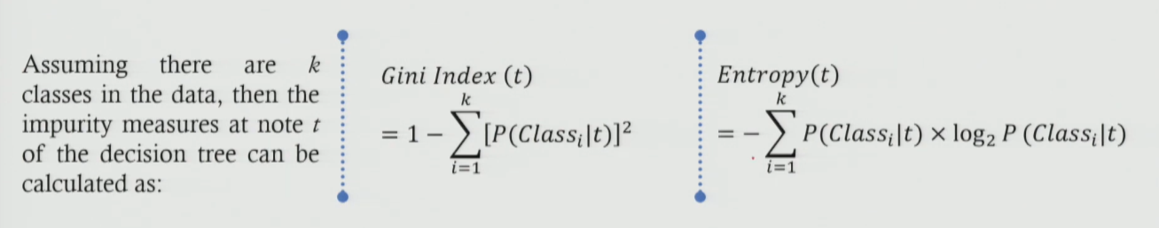

Table 1: Gini and Entropy values for key scenarios — pure vs. maximum impurity
Scenario | Class 1 (%) (100% is 1 and 0% is 0) | Class 2 (%) | Gini Index 1 − Σp² | Entropy −Σp·log₂(p) | Impurity Level
All in Class 1 | 100% | 0% | 1 − (1² + 0²) = 0 | −(1·log₂1 + 0·log₂0) = 0 | Zero ✓ (Pure-no impurity)
All in Class 2 | 0% | 100% | 1 − (0² + 1²) = 0 | −(0·log₂0 + 1·log₂1) = 0 | Zero ✓ (Pure)
50-50 Split | 50% | 50% | 1 − (0.5² + 0.5²) = 0.5 ← MAX | −(0.5·log₂0.5 + 0.5·log₂0.5) = 1 ← MAX | Maximum ✗
Node 0 (Root) 64% Yes, 36% No | 64% | 36% | 1 − (0.64² + 0.36²) = 0.46 | — | High (near max)

Key Insight from Impurity Graph
- X-axis: Proportion of observations in Class 1 (0 to 1)
- Both Gini and Entropy: Start at 0 (all in one class) → rise to maximum at 0.5 (50-50 split) → fall back to 0 (all in other class)
- Shape: Inverted U — symmetric around 0.5
- Implication: When splitting a node, we want to move observations AWAY from 0.5 towards either end (0 or 1) → reduce impurity → improve accuracy
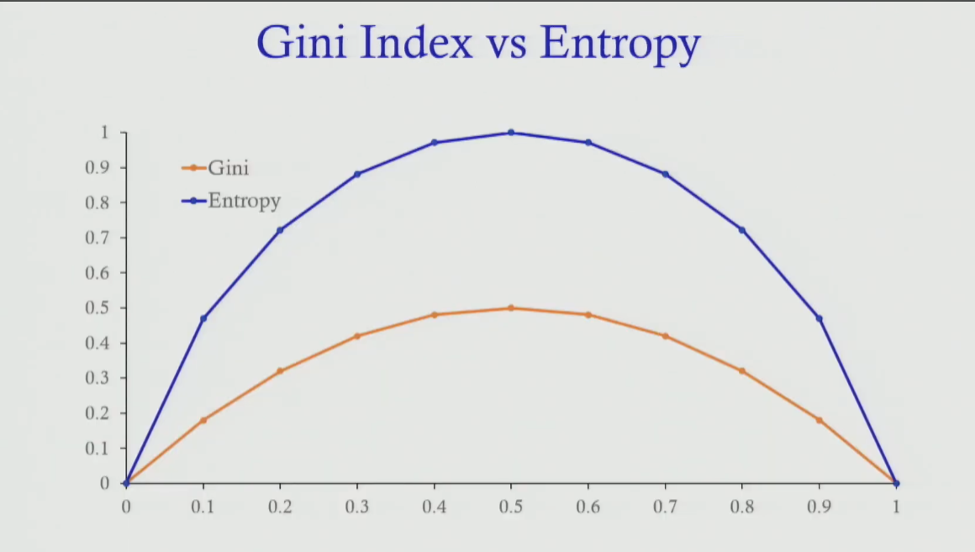
★ Exam tip: Know both formulas. Know that Gini max = 0.5 and Entropy max = 1 (for binary classification). Know that impurity = 0 means pure node (perfect classification). These numbers are commonly tested.

Splitting Logic — How to Choose Variable and Cutoff
- At each node, try ALL variables (age, utilisation, MTBF, oil, etc.) with ALL possible cutoff values
- For each (variable, cutoff) pair: Calculate weighted reduction in impurity after the split

Reduction in Impurity Formula
ΔImpurity = Gini(parent node) − [ w_left × Gini(left child) + w_right × Gini(right child) ]
where w_left = (obs in left child) / (obs in parent) and w_right = (obs in right child) / (obs in parent)
- Choose: The (variable, cutoff) pair that gives the LARGEST ΔImpurity → this is the best split
- Any other variable or cutoff: Will give a smaller reduction in impurity → not chosen
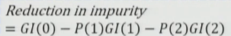
★ Exam tip: Be able to compute ΔImpurity. For Node 0 example: 0.46 − (0.2 × 0.44 + 0.8 × 0.40) = 0.46 − 0.408 = 0.052. Higher ΔImpurity = better split.
Node-by-Node Splitting Trace — Full Tree
Table 2: All nodes — observations, Gini, splitting variable, cutoff, impurity reduction, and result
Node | Obs. Count | Yes% / No% | Gini | Split Variable | Cut-off | Reduction in Impurity | Child Nodes
0 (Root) | 700 total (447 Yes, 253 No) | 64% / 36% | 0.46 | Oil Contamination | 5.5 | 0.052 (Maximum) | → Node 1 (Oil ≤ 5.5) → Node 2 (Oil > 5.5)
1 | 141 total | Oil ≤ 5.5 | 0.44 | Utilisation | 92.05% | 0.38 (Maximum at Node 1) | → Node 3 (Util ≤ 92.05) → Node 4 (Util > 92.05)
2 | 559 total (72% Yes) | Oil > 5.5 72% / 28% | 0.40 | MTBF | 23.95 | 0.11 (Maximum at Node 2) | → Node 5 (MTBF ≤ 23.95) → Node 6 (MTBF > 23.95)
3 (Leaf) | 109 obs. (90 No, 19 Yes) | 17% / 83% | 0.28 | STOP | — | — | Predict: NOT FAIL 83% accuracy
4 (Leaf) | ~35 obs. (88% Yes) | 88% / 12% | 0.21 | STOP | — | — | Predict: FAIL 88% accuracy
5 (Leaf) | 493 obs. (380 Yes, 112 No) | 77% / 23% | 0.35 | STOP | — | — | Predict: FAIL 77% accuracy, 70% support
6 (Leaf) | 66 obs. (~71% No) | 29% / 71% | 0.41 | STOP | — | — | Predict: NOT FAIL 71% accuracy

Node 0 → Split on Oil Contamination (threshold = 5.5)
- Gini at Node 0: 0.46 (high impurity, near-random data)
- After split: Node 1 (141 obs, Gini 0.44) | Node 2 (559 obs, Gini 0.40)
- ΔImpurity: 0.46 − (0.2 × 0.44 + 0.8 × 0.40) = 0.46 − 0.408 = 0.052 ← Maximum possible using any variable/cutoff at this node
- Why 5.5 and not 6 or 7? Tried all cutoff values → 5.5 gives the highest reduction in impurity. Any other cutoff gives less than 0.052.
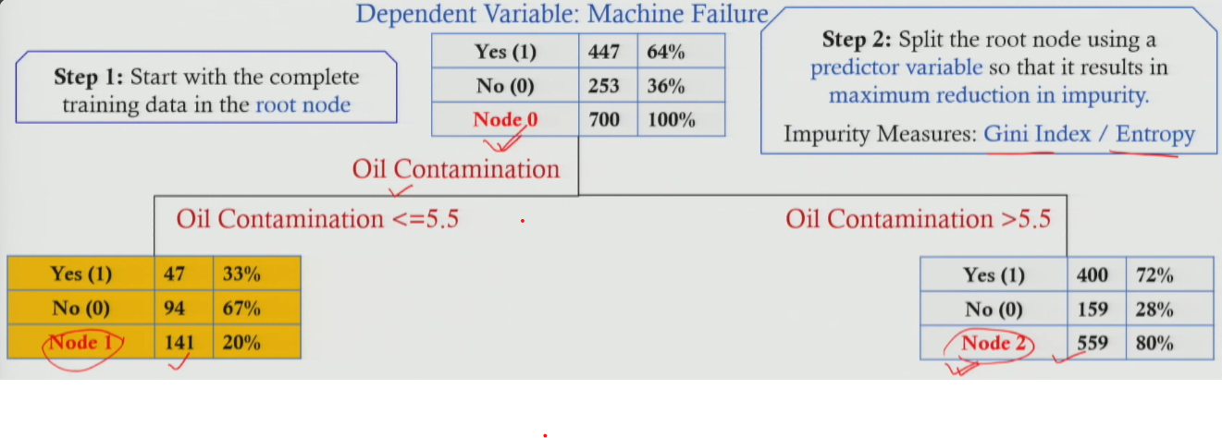
Node 2 → Split on MTBF (threshold = 23.95)
- Gini at Node 2: 0.40
- After split: Node 5 (493 obs, Gini 0.35) | Node 6 (66 obs, Gini 0.41)
- ΔImpurity: 0.40 − (0.7 × 0.35 + 0.09 × 0.41) = 0.11 ← Maximum at Node 2
- Any other variable (age, utilisation, oil) at Node 2: Gives reduction < 0.11 → MTBF is best
Node 1 → Split on Utilisation (threshold = 92.05%)
- Gini at Node 1: 0.44
- After split: Node 3 (109 obs, Gini 0.28) | Node 4 (~35 obs, Gini 0.21)
- ΔImpurity: 0.38 ← Maximum at Node 1
- Note: Node 3 Gini = 0.28 (relatively pure — 83% in one class). Node 4 Gini = 0.21 (very pure — 88% fail predicted).
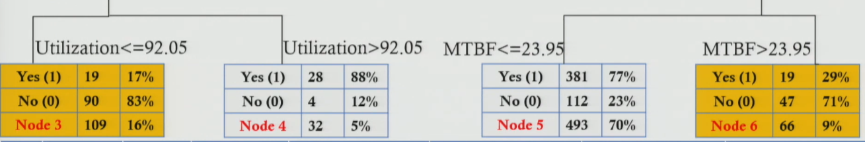
Accuracy Progression — How Each Split Improves Prediction
Table 3: How accuracy improves at each stage of the tree as more information is added
Stage | Information Available | Best Prediction Accuracy | Interpretation
Node 0 (No info) | None — just know the machine exists | 64% (baseline) | Baseline: 64% of all 700 machines failed historically. Pick any machine → 64% chance it will fail.
After Split 1 (Node 2) | Oil Contamination > 5.5 | 72% (+8%) | Knowing oil is high contamination improves accuracy from 64% → 72%. Information has value.
After Split 2 (Node 5) | Oil > 5.5 AND MTBF ≤ 23.95 | 77% (+5%) | Adding MTBF info pushes accuracy further to 77%. More information = better prediction.
Node 4 (Best leaf) | Oil ≤ 5.5 AND Utilisation > 92.05% | 88% (+24%) | Highest accuracy leaf — overutilised but low-contamination machines are very likely to fail (88%).

- Key takeaway: Each split adds information → accuracy increases. This is the fundamental intuition behind decision trees.
- Diminishing returns: Each additional split adds less accuracy improvement than the previous one → reason to stop at some depth
Stopping Criteria — When to Stop Splitting
Table 4: Three stopping criteria used in classification trees
Stopping Criterion | Definition | How Used in This Example
Max Tree Depth (Levels from root) | Stop splitting once the tree reaches a pre-set maximum depth. Prevents model from becoming too complex. | In this example: Depth = 2 used. Depth 1 = oil contamination split. Depth 2 = MTBF / utilisation split. No further splitting beyond that.
Min. Observations per Node | Do not split a node if it contains fewer than a minimum number (or %) of training observations. | Here: 700 total → min = 10% = 70 obs. Node 6 has 66 obs (~9%) → would trigger this stop. Node 4 has ~35 obs (~5%) → also triggers stop.
Min. Reduction in Impurity (Epsilon threshold) | Do not split if the gain in purity (reduction in Gini/entropy) from the best possible split is below a set threshold (epsilon). | e.g. ε = 0.0001. If no variable reduces Gini by at least 0.0001, stop splitting. Prevents tiny, meaningless splits.
Why Stopping is Critical — Overfitting
- If no stopping: Tree keeps splitting → eventually each leaf has just 1 observation → 100% accuracy on training data
- Problem: 100% accuracy on training data but poor accuracy on new (test) data → model "memorised" training data instead of learning patterns
- This is called: Overfitting — the model is too complex, not generalisable
- Fix: Apply stopping criteria (max depth, min obs, min impurity reduction) → produce a simpler, more general model
- Trade-off: Slightly lower training accuracy BUT much better test accuracy → what matters in practice is how well the model predicts NEW data
★ Stopping criteria prevent overfitting. A good model is not one that perfectly fits training data — it is one that accurately predicts UNSEEN data. Always stop before the tree becomes too deep.
★ Exam tip: Overfitting is always asked in ML questions. Define it, explain why it happens in decision trees (too many splits), and name 2–3 stopping criteria that prevent it.
4-Step Algorithm — How to Build a Classification Tree
- Step 1 — Start at root: Place all training data in the root node (Node 0). Calculate initial Gini (or entropy).
- Step 2 — Find best split: For each node, try all possible (variable, cutoff) combinations. Select the one that gives maximum reduction in impurity (ΔImpurity).
- Step 3 — Repeat: Apply Step 2 to each new internal node created. Keep splitting until a stopping criterion is met.
- Step 4 — Stop and classify: At each leaf node, assign the majority class as the prediction. Report probability = proportion of that class in the leaf, and support = proportion of training data in that leaf.

- Stopping criteria applied in Step 3: Max depth | Min observations per node | Min ΔImpurity
- Impurity measure used: Gini index (in this example) — entropy also valid and gives similar results
★ Exam tip: If asked "how is a classification tree built?" — give all 4 steps + stopping criteria + mention Gini/entropy. This is a complete answer for a 10-mark question.
Gini Index vs. Entropy — Quick Comparison
Aspect | Gini Index | Entropy
Formula | 1 − Σp² | −Σp·log₂(p)
Range (binary class) | 0 to 0.5 | 0 to 1
Min value = pure node | 0 | 0
Max value = most impure (50-50) | 0.5 | 1
Computational cost | Lower (no log calculation) | Higher (log function)
Used in this model | ✓ Yes | Covered conceptually only
Practical result | Tends to split into similar-sized nodes | Tends to find more balanced splits
Session Summary
- Root node baseline: 700 obs | 64% failure rate | Gini = 0.46 — high impurity, needs improvement
- Impurity measures: Gini Index = 1 − Σp² | Entropy = −Σp·log₂(p). Both = 0 for pure nodes, maximum at 50-50 split.
- Splitting criterion: Choose (variable, cutoff) with maximum ΔImpurity = Gini(parent) − [w_L × Gini(L) + w_R × Gini(R)]
- Split 1 (Node 0): Oil Contamination at 5.5 → ΔImpurity = 0.052 (best possible)
- Split 2a (Node 2): MTBF at 23.95 → ΔImpurity = 0.11 (best at Node 2)
- Split 2b (Node 1): Utilisation at 92.05% → ΔImpurity = 0.38 (best at Node 1)
- Accuracy progression: 64% (baseline) → 72% (after oil split) → 77%/88% (after 2nd split)
- Stopping criteria: Max depth | Min observations per node | Min ΔImpurity
- Overfitting: No stopping → 100% training accuracy but poor test accuracy. Stopping = essential for generalisation.
- Next session: Python hands-on — implement this exact model in code, reproduce the same output

